**Final Project** Proposal Submission Guidelines



**Data Dynamos**

For HR Data Analysis

**Final Project– Proposal Submission Guidelines**

As part of your current project, you are required to submit a proposal that includes the following:

* **Project Description:** Provide a clear and concise explanation of the project.

|  |  |
| --- | --- |
| **Employee Data** | A comprehensive list of employees, including demographic details such as age, gender, marital status, and job roles. |
| **Performance Rating Data** | Tracks individual performance metrics, capturing data from employee reviews and assessments over time. |
| **Education Level Data** | Provides insights into the education backgrounds of employees, highlighting their qualifications and the correlation with job performance and salary. |
| **Rating Level Data** | Details performance ratings for employees, evaluating their overall contributions and effectiveness in their roles. |
| **Satisfied Level Data** | This contains information on employee satisfaction ratings, categorized by various factors such as job satisfaction and work-life balance. |

* 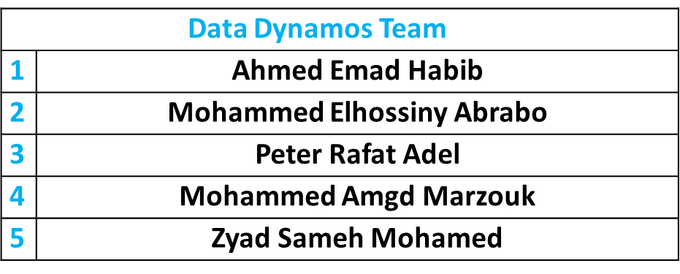**Group Members & Roles:** List all team members along with their assigned roles.





* **Team Leader:** Specify the name of the team leader. **(Ahmed Emad Habib Mohamed)**
* **Objectives:** Outline the main goals of the project.
* We will delve into a comprehensive analysis of our employee dataset, which comprises five key tables. Each table provides critical insights into various aspects of employee performance, satisfaction, and demographics. By examining these tables, we aim to uncover meaningful patterns and relationships that can inform strategic decisions within our organization.
* In addition to collecting additional data for comparison and taking several strategic decisions and working on preparing interactive reports, analyses and forecasts that help in making decisions and preparing this in a visual form to make it easier for decision makers to compare and create an artificial intelligence model equipped to answer any question that helps in making a decision.
* In addition to preparing a special report for each department to help it develop plans appropriate to the actual situation.
* **Tools & Technologies:** Mention the tools and technologies that will be used.
* **Milestones & Deadlines:** Define key project milestones with their respective deadlines

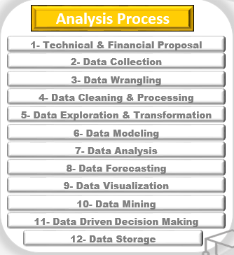

**We are ready to have the entire project completed and discussed in week 22 of the Scholarship, corresponding to April 25/04/2025.**

* **KPIs (Key Performance Indicators):** Each team should customize the following KPIs based on their project requirements:

**Data Cleaning & Processing:**

* Ensure data is clean, structured, and well-documented.
* Complete data processing efficiently within the project timeline.

**Analysis & Insights:**

* Identify key analytical questions relevant to business needs.
* Provide clear, data-driven insights with effective visualizations.

**Forecasting & Predictions:**

* Use reliable models to generate accurate predictions.
* Compare multiple forecasting approaches for better accuracy.

**Visualization & Reporting:**

* Develop an interactive and user-friendly dashboard.
* Ensure fast and smooth dashboard performance.

**Final Documentation & Presentation:**

* Deliver a well-structured final report covering key findings.
* Provide actionable recommendations based on the analysis.

|  |
| --- |
| **Data Dynamos** |

